Clocks with slowPulse bug:

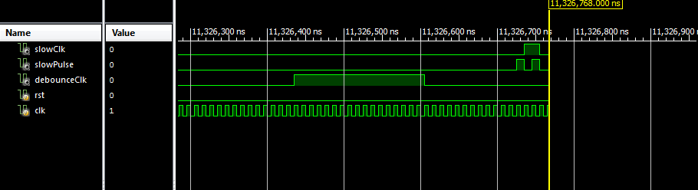

Slow clock, slow pulse, debounce clock

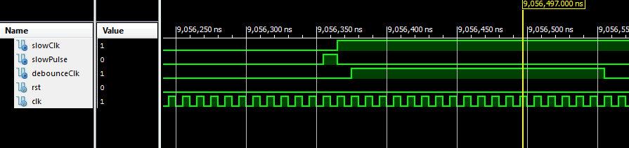

Randomize LEDs:

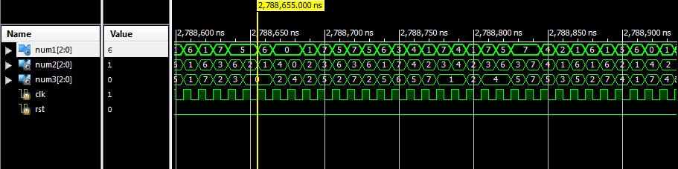

Debouncing with btnE: ACTUAL

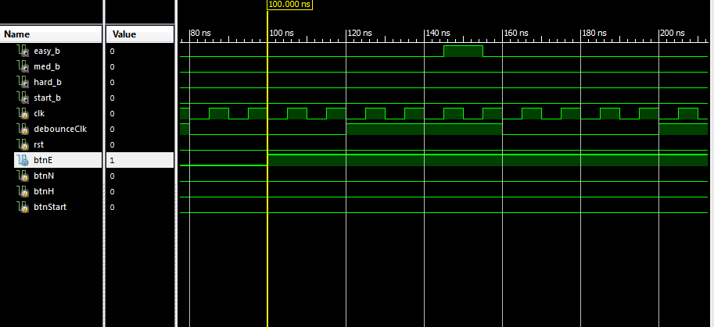

Entire module:

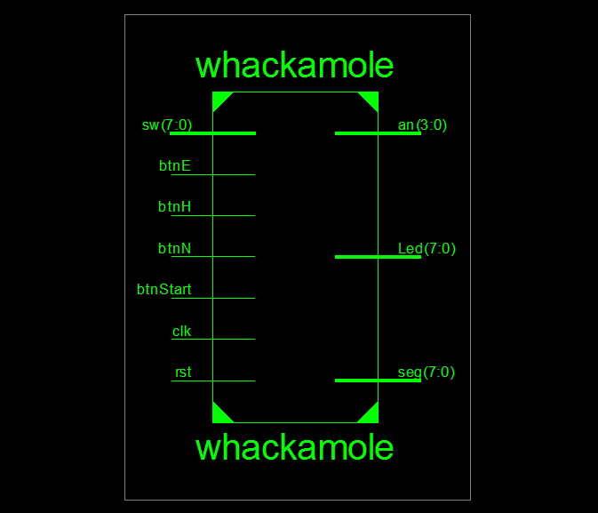

Debounce buttons:

